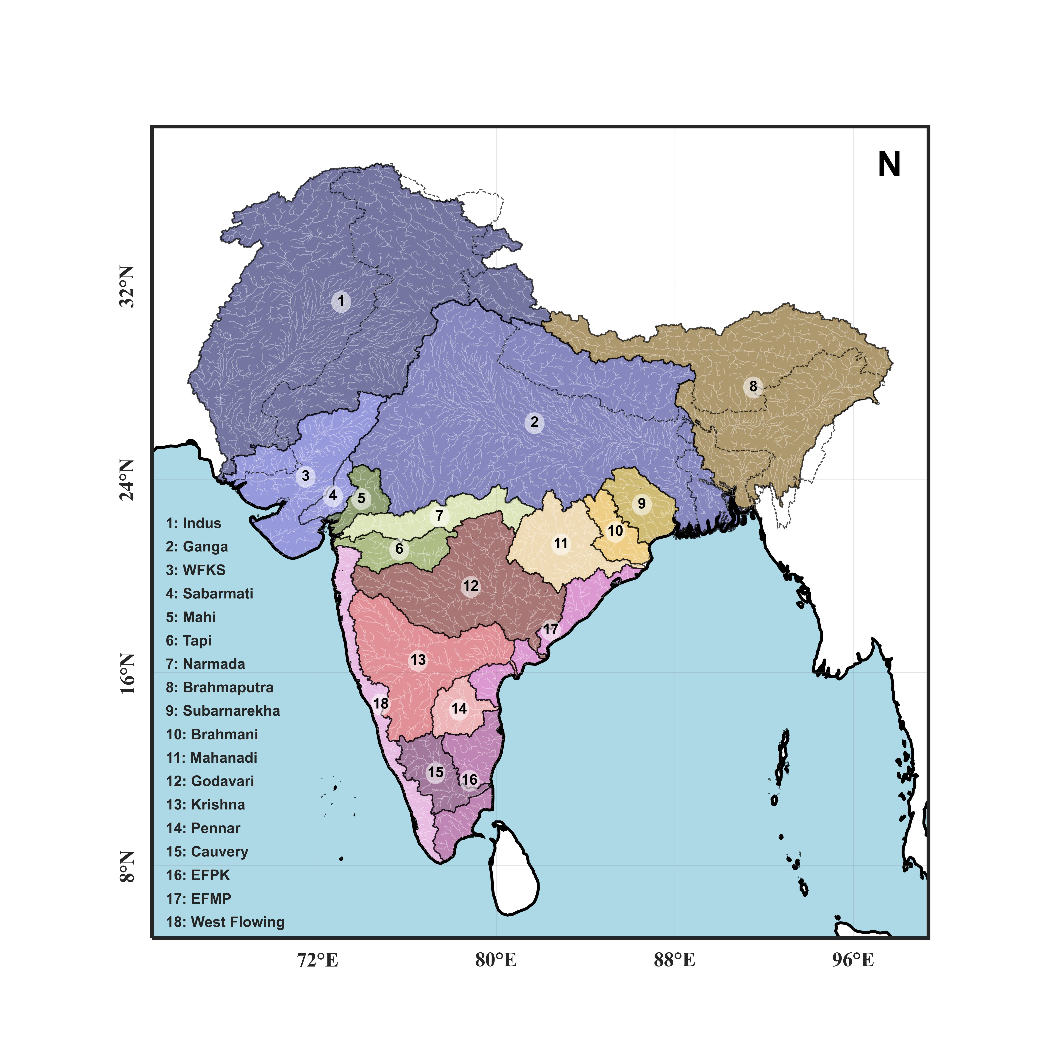

**Fig. 1** Study area showing various river basins of South Asia, including the transboundary extents of Indus (1), Ganga (2), and Brahmaputra (8).

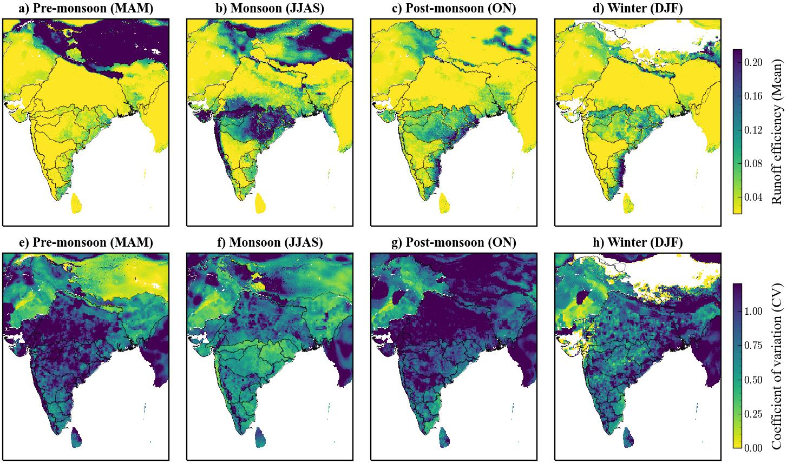

***Fig. 2.*** *Seasonal mean and variance of Runoff efficiency for pre-moonsoon, monsoon, post-monsoon, and winter seasons.*



***Fig. 3*** *Seasonal mean variation in runoff efficiency and precipitation over different basins of South Asia.*

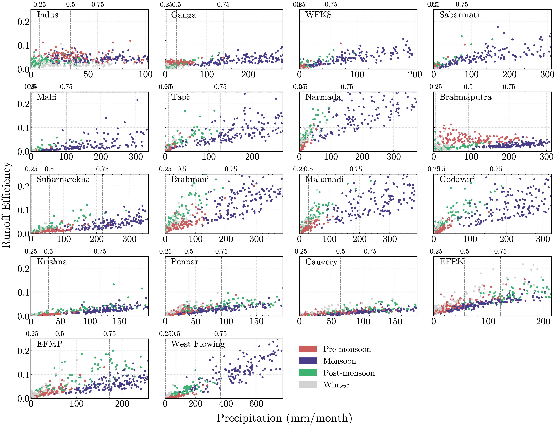

***Fig. 4*** *Precipitation vs runoff efficiency relation for different basins over the study area.*



***Fig. 5*** *Mean runoff efficiency over different basins for a fixed range of precipitation a) 50-100 mm/month; b) 100-150 mm/month; c) 150-250 mm/month.*

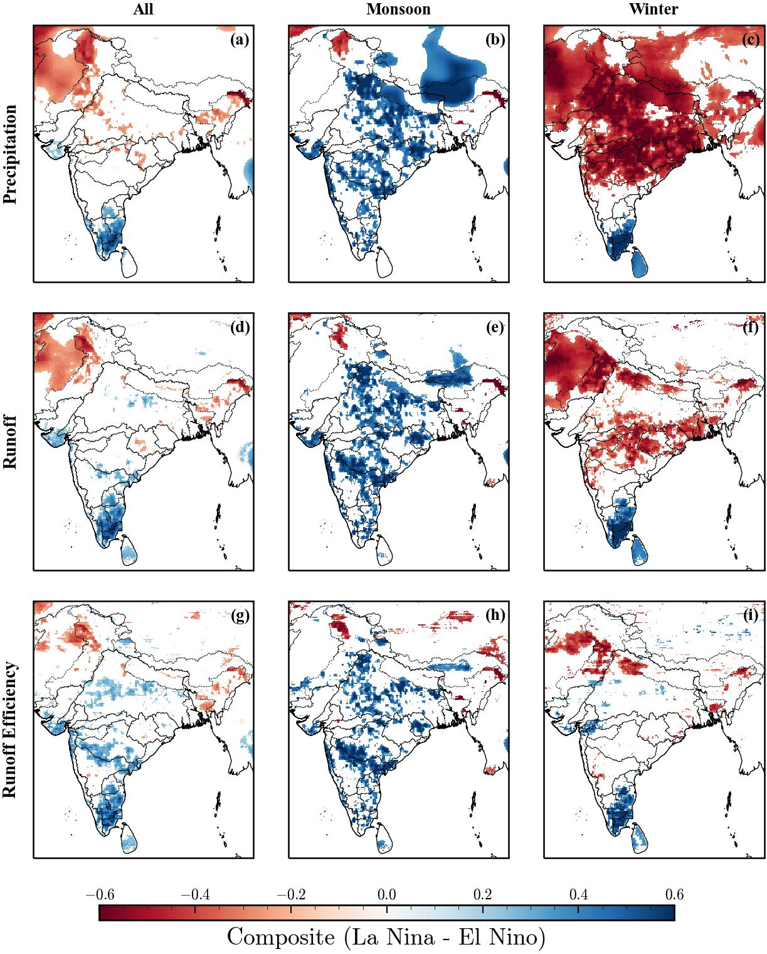

**Fig. 6** Map of the composite analysis (El Niño- La Niña) of Precipitation, runoff, and runoff efficiency for different seasons. Only regions passing the Mann-Whitney test at a 5% level significant level are shown.



**Fig. 7** Composite analysis (El Niño-La Niña) result of the regional average of Precipitation, runoff, and runoff efficiency for the Monsoon season. ‘*’ shows the regions showing statistically significant differences between El Niño and La Niña events. The number represents the ratio between two phases.



**Fig. 8** Trend analysis of runoff efficiency in the monsoon season during 1980-2021 over different basins of India.



**Fig. 9** Scatter plot showing precipitation vs runoff efficiency with color indicating the data points belong to different periods.